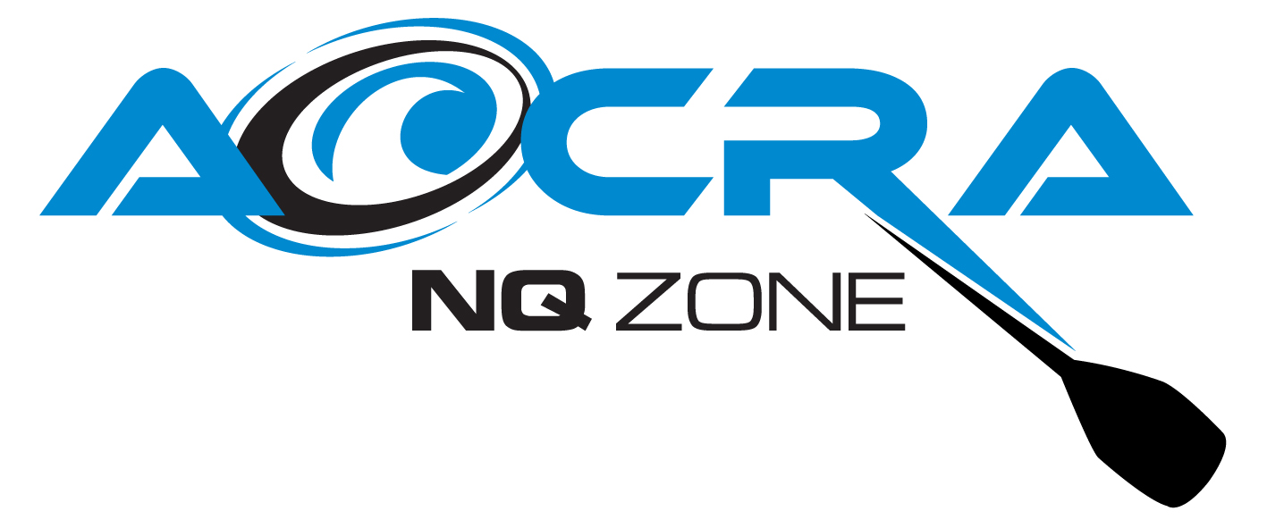

Vehicle Inspection Checklist
Vehicle description:
Vehicle registration:  Date of inspection: | Driver’s name:

What should I check before operating the vehicle | Yes | No
Oil level (IRB)
Parking brake – hold against slight acceleration (Equip trailer)
Lights – clearance, headlights, tail, licence plate, brake, indicator turn signals, hazard, reverse (IRB & Equip trailer)
Check spare tyre (IRB & Equip trailer)
Check tow hitch (IRB & Equip trailer)
Safety chain (IRB & Equip trailer)
Motor prop fitted for towing (IRB)
Motor propeller guard fitted for operation (IRB)
Name of person undertaking vehicle inspection:
Signature:
Vehicle faults to be reported immediately:

REMEMBER – What should I do before vehicle operation
- Initially read, understand and follow the manufacturer’s operating manual. This will provide a wide range of information relative to the vehicle.
- Know how to operate the vehicle and use any related equipment or attachments safely.
- Be familiar with the location and function of all the controls.
- Develop a routine method of inspecting the vehicle.
- If equipment is unsafe to operate, an “Out of Service” tag must be immediately affixed to the Equipment.
- Report IMMEDATELY any equipment faults to AOCRA NQ Zone Secretary, Tania Moohin 0417648009 – moohinpc@bigpond.com

On completion – return to AOCRA NQ Zone Secretary – moohinpc@bigpond.com,
6 Polly Crescent Mackay 4740

